COINSTAC Installation Instructions for Windows 10 Pro

## Introduction

The Collaborative Informatics and Neuroimaging Suite Toolkit for Anonymous Computation, User Interface (COINSTAC) is software created to foster collaborative research by removing large barriers to traditional data-centric collaboration approaches. It is a desktop application that can be run on the major three operating systems (Windows, Mac, and Linux).

## Installation

Below are instructions for how to set up COINSTAC on your computer. The following steps should be taken, which are explained below:

1. Verify System Requirements
2. Install Docker
3. Download and Run COINSTAC Application

## Verify System Requirements

Use a Windows 10 Professional 64-bit computer that has at least 8 GB of memory.

## Install Docker

Log into an account with Administrator privileges and install Docker Community Edition for Windows from this link:

<https://store.docker.com/editions/community/docker-ce-desktop-windows>

### Verify Installation

Check that docker is installed by opening a Powershell window and typing:

### Run Application

You should see a similar message, probably with a different version and build:

Docker version 18.03.1-ce, build 9ee9f40

### Give Privileges to Accounts Without Administrator Privileges

If you want to run COINSTAC on another account without Administrator privileges, then do the following:

1. Close Docker
2. Search for Windows Computer Management in the search box on the left side of your taskbar.
3. Run Windows Computer Management as an Administrator. You should see this window.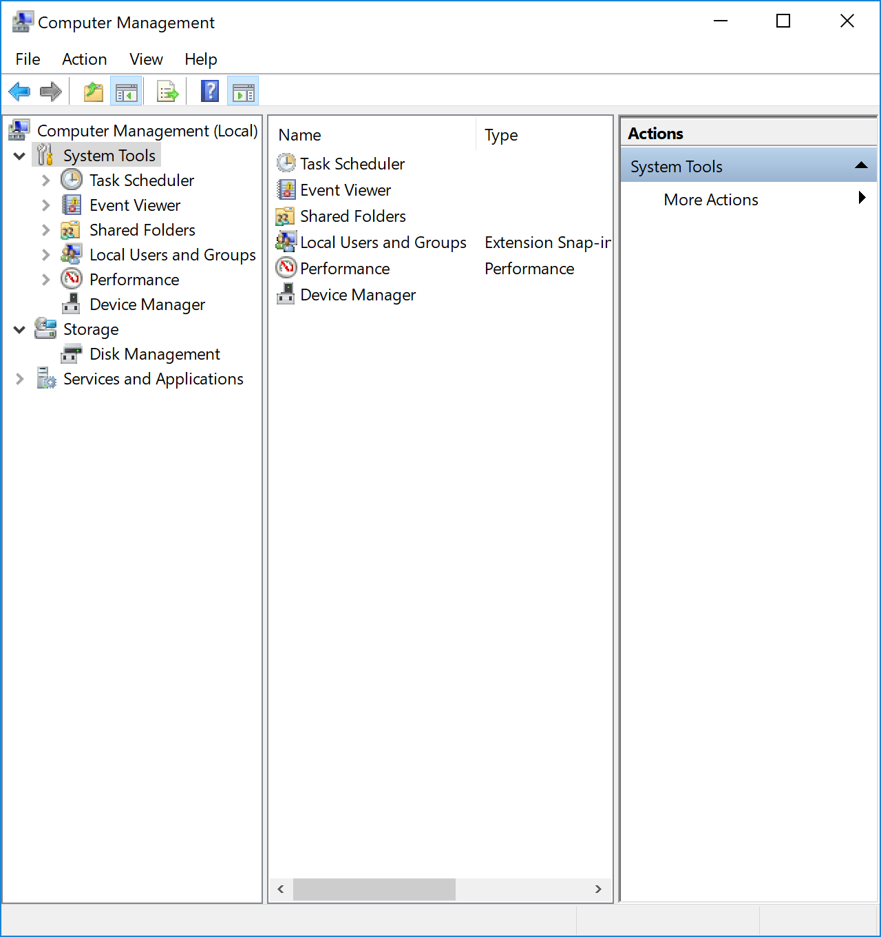
4. Click on System Tools and then Local Users and Groups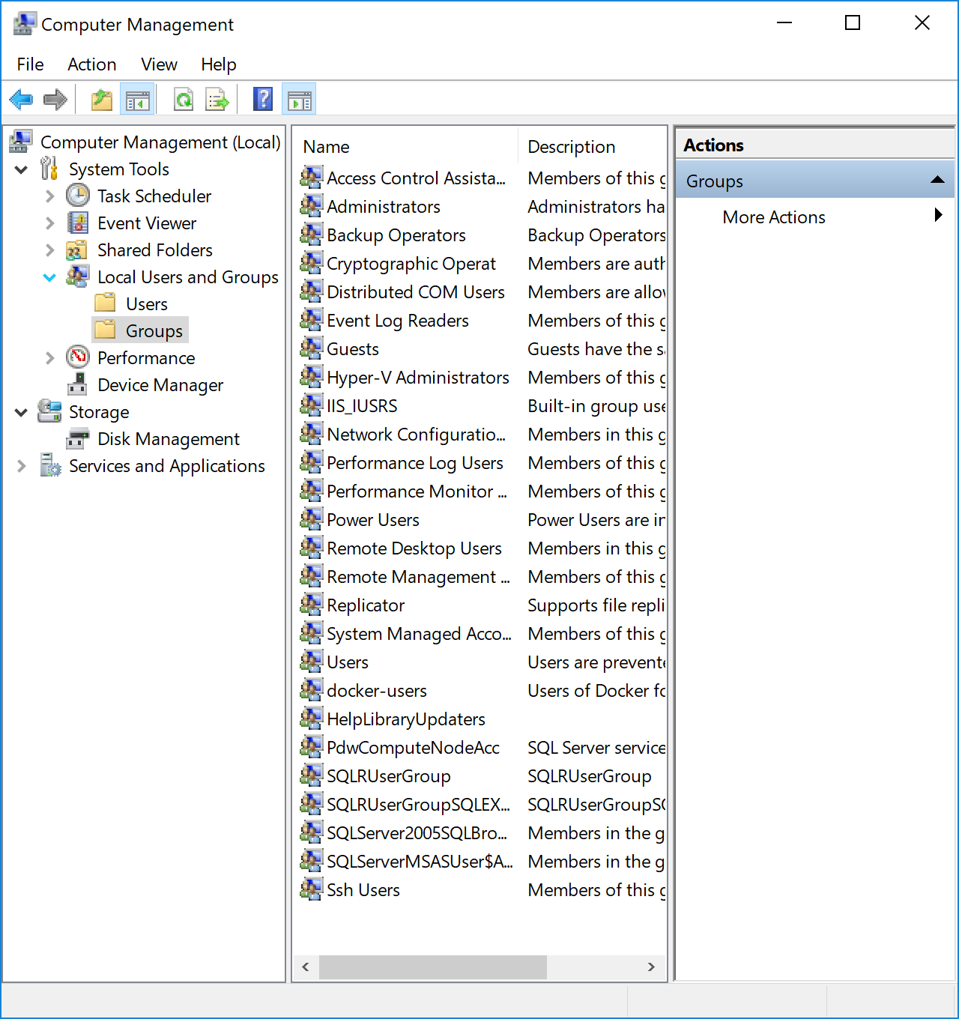
5. Right click the **docker-users** group and click "Add to Group..."
6. A dialog box called "docker-users Properties" will appear.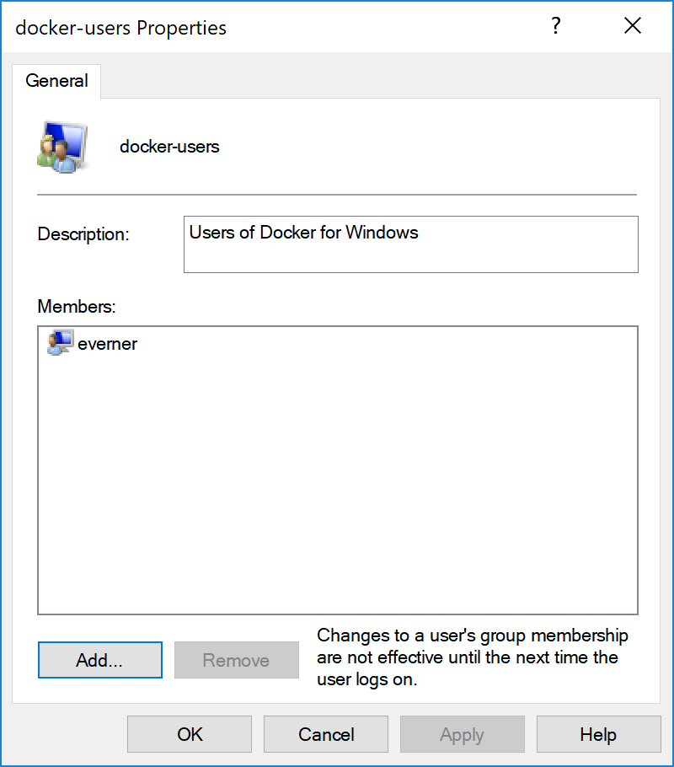
7. Click "Add..."
8. Click "Advanced..."
9. Make sure "Select this object type:" is set to "Users or Built-in security principals"
10. Click "Find Now"
11. Select the user account on which you want to run COINSTAC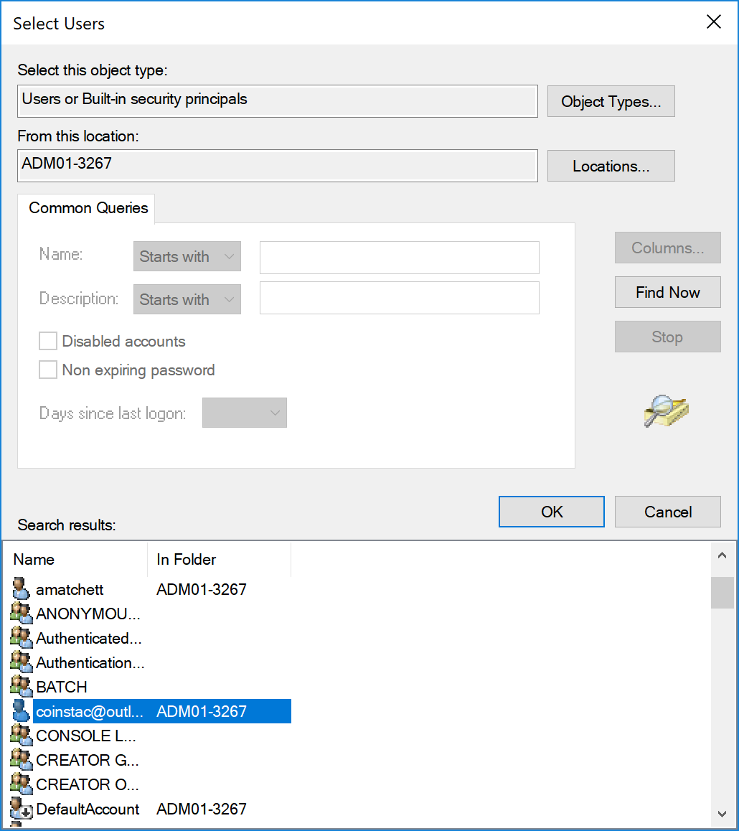
12. Click OK
13. Click OK
14. Click OK
15. Add the same user to Hyper-V Administrators using the same method described above (steps 5-14).
16. Exit from Windows Computer Management.
17. Sign out of the Administrator account.
18. Sign out of the account with which you want to run COINSTAC for the group permissions changes to take effect.
19. Sign back into the account without Administrator privileges and run Docker for Windows.

### Running Docker

To run Docker on Windows:

* Enter "docker" into the search prompt on your taskbar. This will bring up Docker for Windows as the best match.
* Click on Docker for Windows.

### Possible Docker Errors

#### Possible Error #1

After installing Docker on Windows 10, you may see the following error.

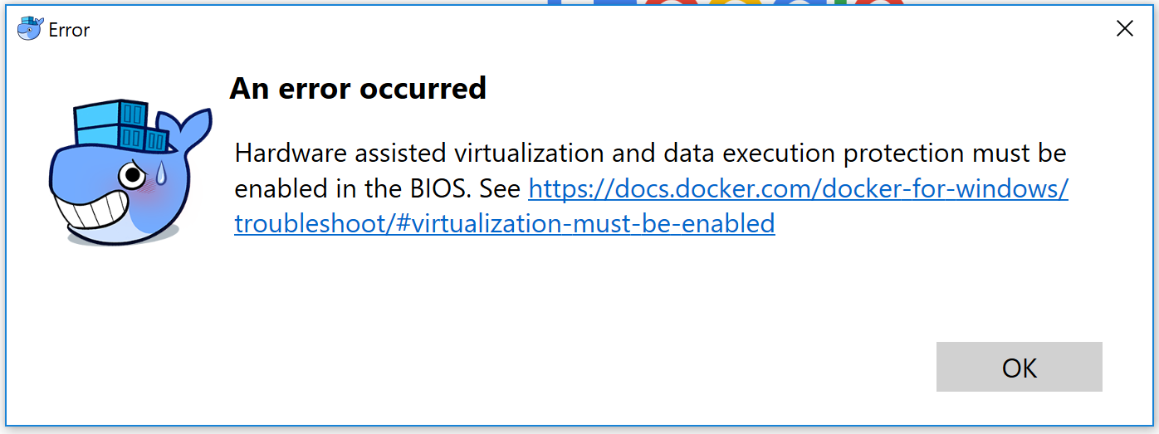

To fix this error, you will need to enable virtualization on your computer's BIOS. Follow this [guide](https://blogs.technet.microsoft.com/canitpro/2015/09/08/step-by-step-enabling-hyper-v-for-use-on-windows-10/) to accomplish that. To get to the BIOS on Windows 10, you can use this [guide](https://www.laptopmag.com/articles/access-bios-windows-10).

#### Possible Error #2

You may also get this error when you launch Docker or run COINSTAC:

Docker hv-sock proxy (vsudd) is not reachable

at Docker.Core.Pipe.NamedPipeClient.Send(String action, Object[] parameters) in C:\gopath\src\[github.com](http://github.com/)\docker\pinata\win\src\Docker.Core\pipe\NamedPipeClient.cs:line 36

at Docker.Actions.DoStart(SynchronizationContext syncCtx, Boolean showWelcomeWindow, Boolean executeAfterStartCleanup) in C:\gopath\src\[github.com](http://github.com/)\docker\pinata\win\src\Docker.Windows\Actions.cs:line 67

at Docker.Actions.<>c__DisplayClass14_0.<Start>b__0() in C:\gopath\src\[github.com](http://github.com/)\docker\pinata\win\src\Docker.Windows\Actions.cs:line 51

at Docker.WPF.TaskQueue.<>c__DisplayClass19_0.<.ctor>b__1() in C:\gopath\src\[github.com](http://github.com/)\docker\pinata\win\src\Docker.WPF\TaskQueue.cs:line 59

To fix this error:

* Click on Show Hidden Icons (^) on your taskbar. You'll see a group of small icons.
* Right click on the Docker icon 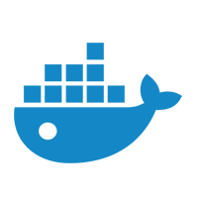.
* Click on Settings.
* Click Reset and then Reset to Factory Defaults. A window will appear asking if you are sure you want to reset.
* Click the Reset button.

### Verify Docker is Running

Before starting COINSTAC, verify that Docker is running on your computer by using one of the methods below.

#### Method #1

You can verify that Docker is running by hovering over the Docker icon  on your taskbar. You should see a message that Docker is running.

#### Method #2

Open a Powershell window and type:

docker ps

You should see an output like this:

CONTAINER ID IMAGE COMMAND CREATED STATUS PORTS NAMES

If you see an error message, then you have to start Docker.

## Download and Run COINSTAC Application

### Download

To download the COINSTAC application, go to this page and download the latest release:

<https://github.com/MRN-Code/coinstac/releases/>

* Download the file named **coinstac-win32-x64.zip**.
* After the download is complete, extract the zip file to a folder on your computer.

### Give Permission to Run Application

After extraction, open the extracted folder and double click on the file named 

You'll see this window warning you about an unrecognized app. This warning will only be issued once every time you open a new version of COINSTAC.

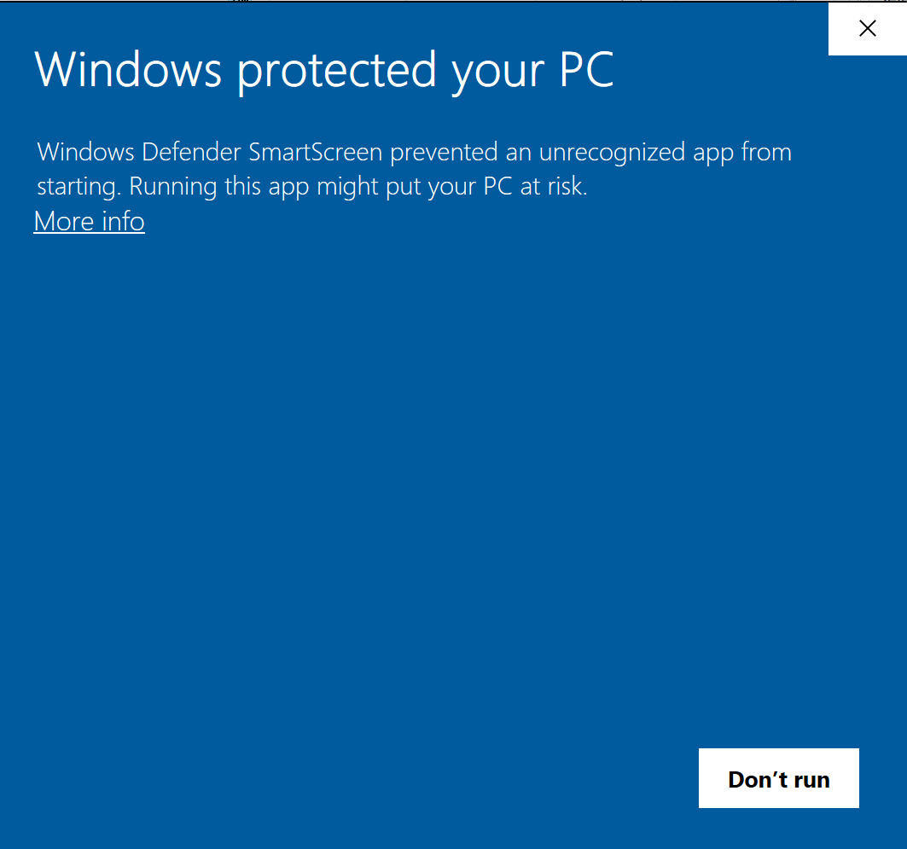

* Click More Info
* Click Run anyway

### Run Application

After you have given your computer permission to run the application, double click on the  file again.

Docker will ask you to enable Hyper-V and Container features. Enable those features. Do not click on the button to enable using Windows containers.

### Docker Drive Permissions

When you run a pipeline for the first time, you will be prompted to share data with Docker on your computer. Pick the drives that contain the data you want to use with COINSTAC or on which you will run COINSTAC (usually at least C drive). You'll have to enter your password to complete this step.